EXNO: 7 CALCULATION AND VERIFICATION OF FREQUENCY DEVIATION AND MODULATION INDEX OF FM SIGNALS USING MATLAB SIMULATION
NAME:V.RUSHMITHA
DATE:08/10/2026
Objectives:
1. To generate a Frequency Modulated (FM) signal in MATLAB using specified carrier and
message signal parameters.
2. To calculate and verify the frequency deviation of the FM signal from the given carrier
frequency and modulating signal parameters.
3. To determine and verify the modulation index of the FM signal using the relationship
between frequency deviation and message frequency.
4. To analyze the effect of message frequency on frequency deviation and modulation
index, and verify their relationship through MATLAB simulation
Procedure
1. Open MATLAB and create a new script file.
2. Clear the command window, workspace variables, and close all previously opened figure
windows using:
Clc;
Clear;
close all;
3. Define the message signal parameters:
● Message amplitude A_m=2V
● Message frequency f_m=500Hz
4. Define the carrier signal parameters:
● Carrier amplitude A_c=1V
● Carrier frequency f_c=10000Hz
5. Define the frequency sensitivity constant k_f, sampling frequency f_s, and simulation
duration T
6. Generate the time vector using:
t = 0:1/fs:T;
7. Generate the message signal using:
m = Am*cos(2*pi*fm*t);
and observe the sinusoidal waveform.
8. Calculate the frequency deviation of the FM signal using:
Δf=kf. Am
9. Calculate the modulation index using: β=Δf/fm
10. Generate the FM signal using:
fm_signal = Ac*cos(2*pi*fc*t + beta*sin(2*pi*fm*t));
where the carrier frequency varies according to the message signal.
11. Plot the message signal in the first subplot and label the axes appropriately.
12. Plot the FM signal in the second subplot and observe the variation in instantaneous
frequency.
13. Display the carrier frequency, message frequency, message amplitude, and frequency
sensitivity in the MATLAB command window using fprintf statements.
14. Display the calculated frequency deviation and modulation index values in the command
window.
15. Verify the modulation index by recomputing it using:
β=Δf/fm
and compare the result with the previously calculated value.
16. Use a conditional statement (if-else) to check whether both modulation index values are
equal within a small tolerance.
17. Display the verification result as:
● "Verification Successful" if both values match.
● "Verification Failed" otherwise.
18. Execute the MATLAB program and observe the message signal, FM signal, calculated
frequency deviation, modulation index, and verification result.
PROGRAM (MATLAB CODE)
% Calculation and Verification of Frequency Deviation
% and Modulation Index of FM Signal
clc;
clear;
close all;
%% Message Signal Parameters
Am = 2; % Message amplitude (V)
fm = 500; % Message frequency (Hz)
%% Carrier Signal Parameters
Ac = 1; % Carrier amplitude (V)
fc = 10000; % Carrier frequency (Hz)
%% FM Parameters
kf = 250; % Frequency sensitivity (Hz/V)
fs = 100000; % Sampling frequency (Hz) T = 0.01; % Simulation duration (s)
%% Time Vector
t = 0:1/fs:T;
%% Message Signal
m = Am*cos(2*pi*fm*t);
%% Frequency Deviation
delta_f = kf*Am;
%% Modulation Index
beta = delta_f/fm;
%% FM Signal
fm_signal = Ac*cos(2*pi*fc*t + beta*sin(2*pi*fm*t));
%% Display Parameters
fprintf('Carrier Frequency (fc) = %.0f Hz\n',fc);
fprintf('Message Frequency (fm) = %.0f Hz\n',fm);
fprintf('Message Amplitude (Am) = %.0f V\n',Am);
fprintf('Frequency Sensitivity (kf) = %.0f Hz/V\n',kf);
fprintf('\nFrequency Deviation (Delta f) = %.2f Hz\n',delta_f);
fprintf('Modulation Index (Beta) = %.2f\n',beta);
%% Verification
beta_verify = delta_f/fm;
fprintf('Verified Modulation Index = %.2f\n',beta_verify);
%% Verification Check
tolerance = 1e-6;
if abs(beta - beta_verify) < tolerance
fprintf('\nVerification Successful\n');
else
fprintf('\nVerification Failed\n');
end
%% Plotting
figure;
subplot(2,1,1);
plot(t,m,'LineWidth',1.5);
grid on;
title('Message Signal');
xlabel('Time (s)');
ylabel('Amplitude (V)');
subplot(2,1,2);
plot(t,fm_signal,'LineWidth',1);
grid on;
title('FM Signal'); xlabel('Time (s)');
ylabel('Amplitude (V)');
OUTPUT
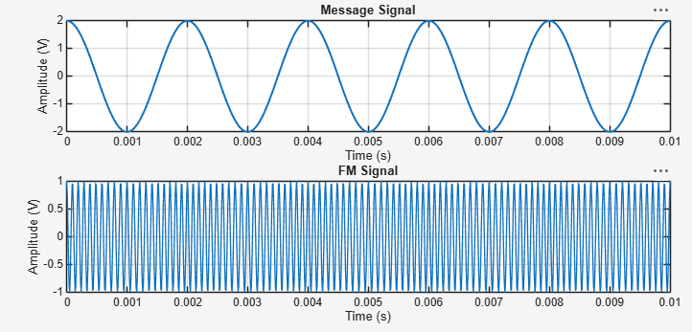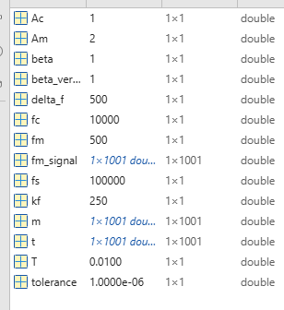

OUTPUT GRAPH Example (Just for Understanding)
For:
A_m=2V
f_m=500Hz
k_f=1000Hz/V
Frequency deviation:
Δf=k_f A_m
Δf=1000×2=2000" Hz"
Modulation index:
β=Δf/f_m
β=2000/500=4
Result
1. Generate and visualize carrier, message, and FM signals using MATLAB.
2. Calculate the theoretical frequency deviation and verify it from the simulated FM waveform.
3. Calculate the FM modulation index and verify the relationship β = Δf/fm.
4. Interpret the effect of changing message frequency on modulation index and verify that, for constant
frequency sensitivity and message amplitude, the peak frequency deviation remains constant.

